HTML Level 3

1.creating Table tag

2. Semantic in table -for naming better table

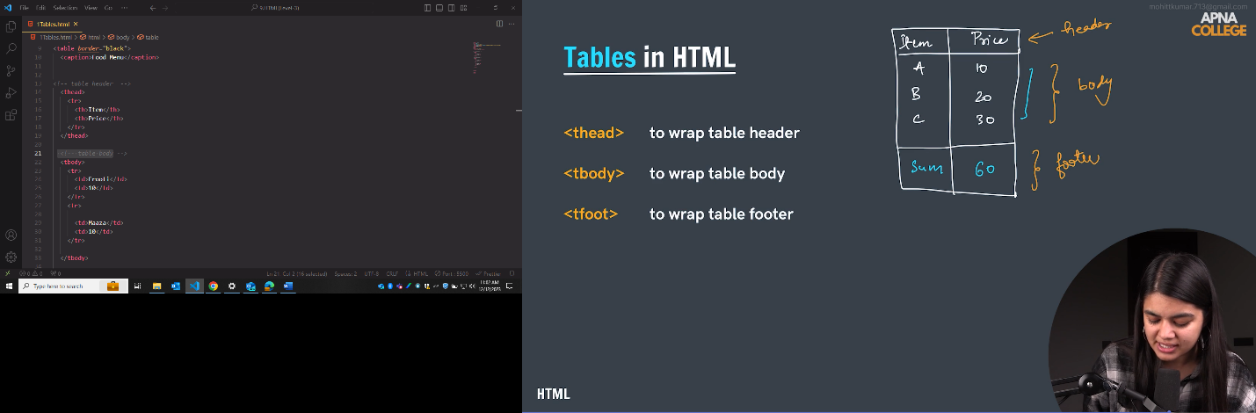

\

**3.RowSpan and Colspan**

Practice Q7

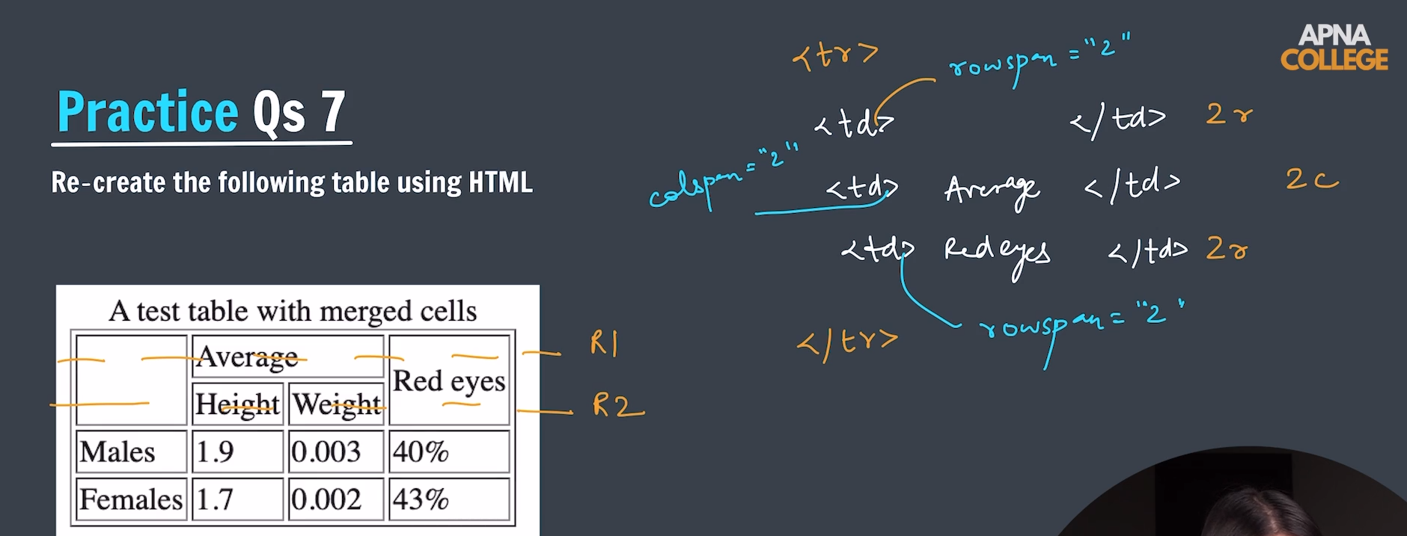

Forms

Label -For🡪 (Connecting id)

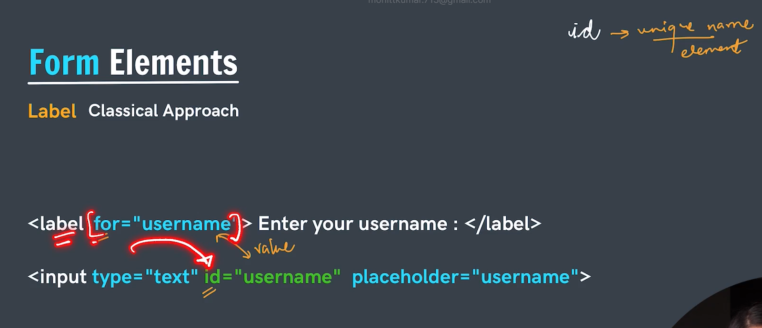

Input ki help se button banana

Button se button banana

**Name ki value same ho same group** ke liye baaki value alag ho

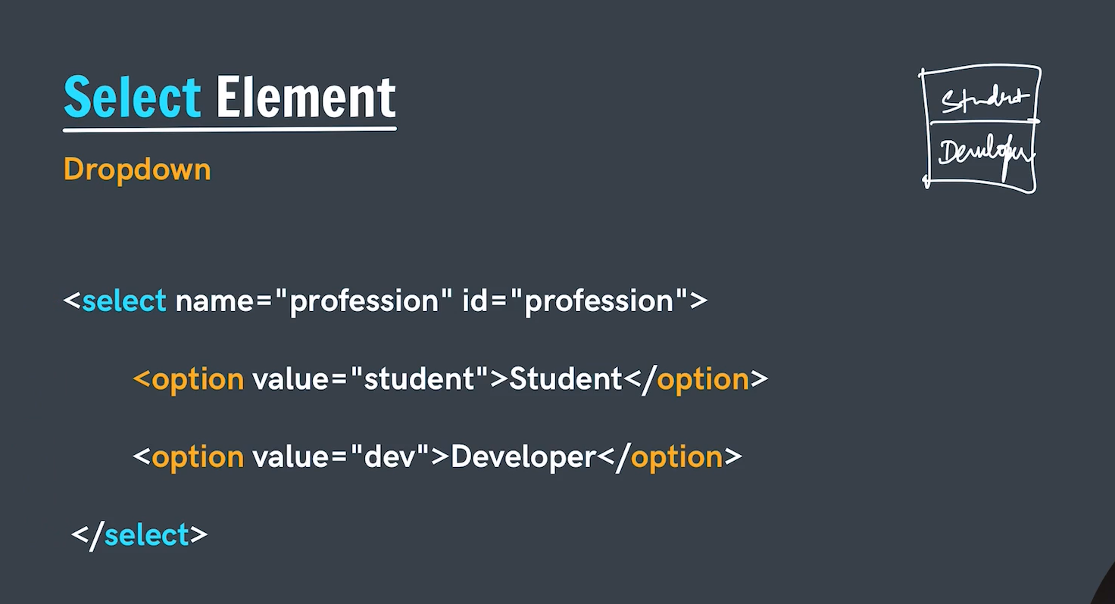

Imp:-Name is value server pr dikhega